Icy Spring Bracelet

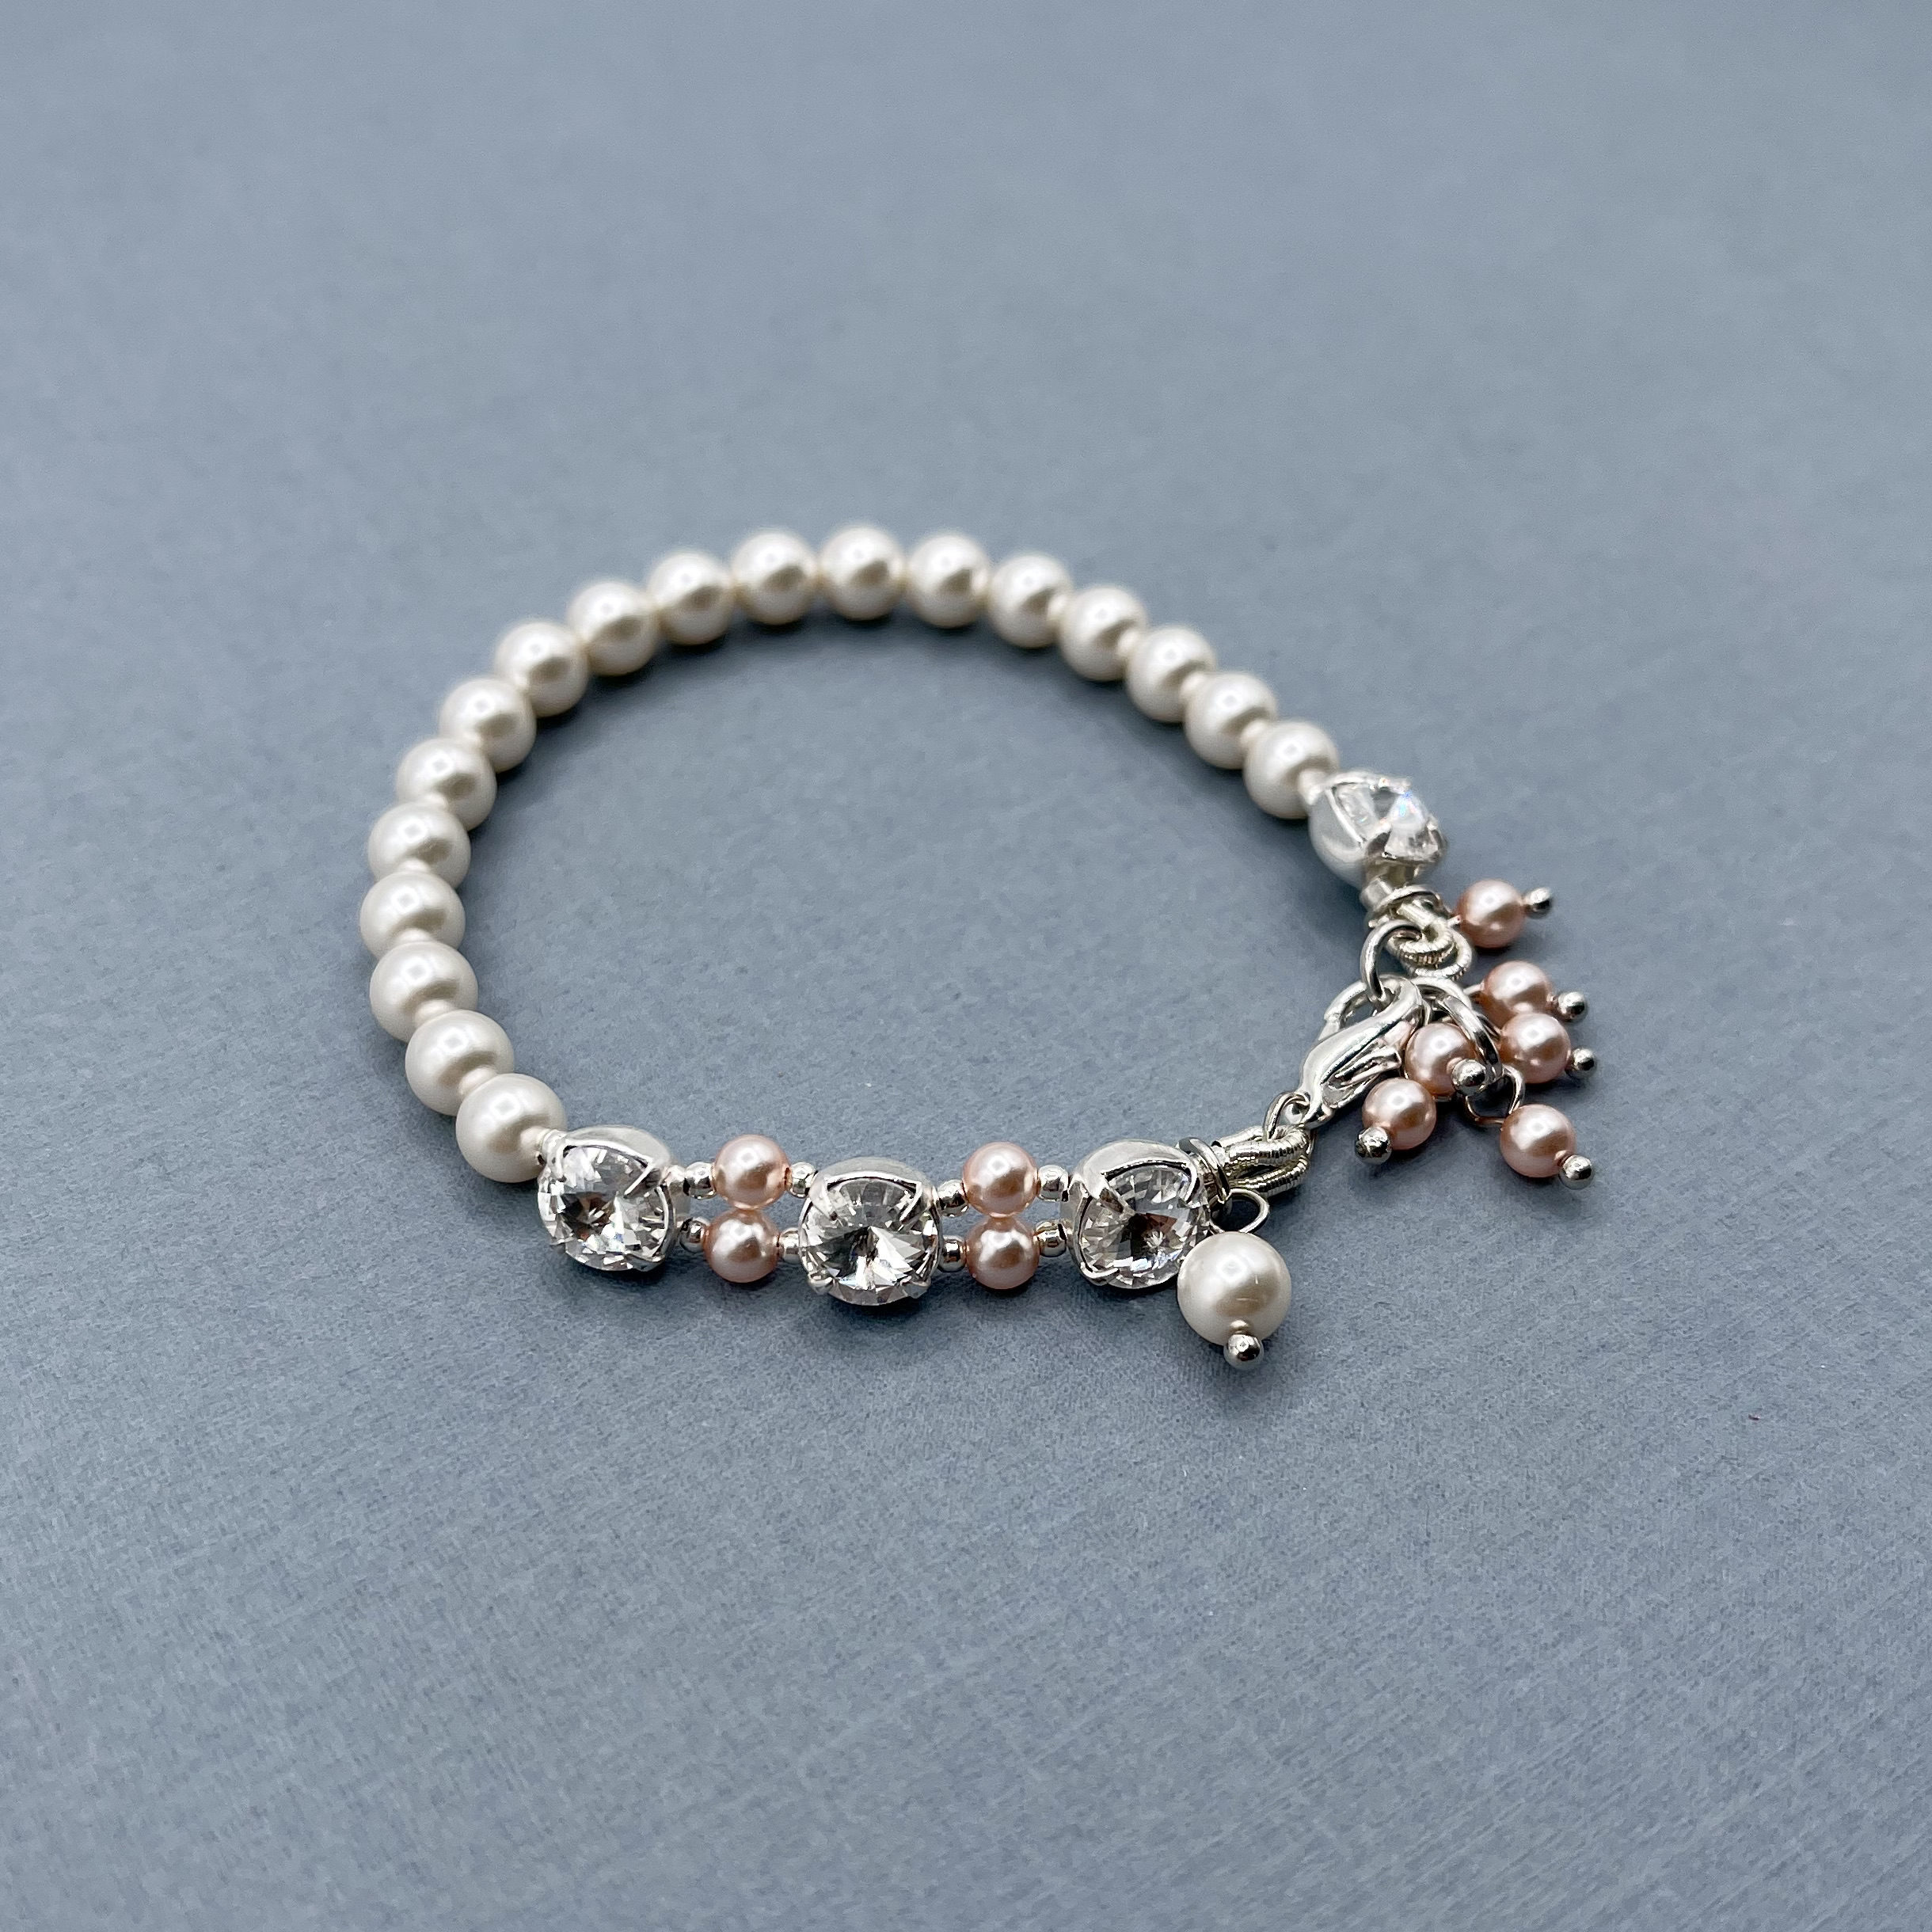

Designed by Denise Yezbak Moore
Featuring Crystals by Preciosa
For John Bead

Materials:

10 pcs Preciosa Maxima nacre pearl 4mm rosaline (131020-008)
19 pcs Preciosa Maxima nacre pearl 6mm white (131024-001)
04 pcs Preciosa sew-on rivoli ss34 crystal silver setting (10027931)
03 pcs John Bead silver plated jump ring 6mm
03 pcs Jonn Bead silver plated jump ring 4mm
02” Beadalon French wire, 0.7mm silver plated (25032290)
04 pcs Beadalon® crimp tube size 2 silver tone
07 pcs John Bead silver beaded head pin
01 pcs John Bead silver plated lobster clasp
12 pcs Beadalon® size 1 crimp beads silver
22” Beadalon® 49 strand stainless steel bead stringing wire, 0.38mm
(JW10T-0)

Alternate Bracelet Colors –
29 pcs Preciosa maxima nacre pearl 4mm pearlescent red
(131020-024)
29 pcs Preciosa maxima nacre pearl 4mm bordeaux
(131020-022)
05 pcs Preciosa maxima nacre pearl 6mm pearlescent red
(131024-024)
04 pcs Preciosa maxima nacre pearl 6mm Bordeaux
(131024-022)

Tools:
Beadalon classic nipper tool (JTNIP1)
Beadalon slim line round nose pliers (201A-014)
Beadalon 2 slim line chain nose pliers (201A-011)
Beadalon standard crimp tool (JTCRIMP1)

Time: Less than 1 hour
Instructions:

Gray Crystal Bracelet
- Cut ½” of French wire. Set aside
- Cut 11” of beading wire.
- String crimp tube, 1 length of French wire, pass wire back through crimp tube and crimp.
- Repeat steps 1-3 one time.
- String beading wires through each side of rivoli crystal.
- On each side of wires, string crimp bead, Rosaline pearl, crimp bead, rivoli crystal, crimp bead, Rosaline pearl, crimp bead, rivoli crystal and crimp bead.
- Bring beading wire together and string 18 white pearls 6mm.
- Separate strands, string crimp bead on each strand and rivoli crystal through each strand.
- On strand one - String crimp tube, French wire, pass wire back through crimp tube, and crimp. Repeat on strand two.
- Using 4mm jump ring, connect lobster clasp to right side of bracelet.
- Attach 6mm jump rings to left side of bracelet.
- Attach 3 jump rings 6mm to other side of bracelet.
- Using beaded head pin, string rosaline pearl and form a simple loop. Repeat 6 times.
- Using bead head pin, string white 6mm pearl and form a simple loop.
- Using a 4mm jump ring, attach white pearl dangle around crimp tubes next to lobster clasp.
- On the other side of bracelet, using a 4mm jump ring, attach rosaline pearl around the crimp tubes next to lobster clasp.
- Attach 2 rosaline dangles to each of the 6mm jump rings at end of bracelet. Attach 1 rosaline dangle to last 6mm jump ring.

Alternative Design –

